Facebook Ads
Assignment

Name: Josva Rochi. R
Email: josva6438@gmail.com

1.) Campaign objective:
Objective:
Brand Awareness + video views

Reasoning:
Sky Asia is an early stage of paid advertising and wants to drive consideration among its target audience. Their goal is to reach 12 million category users and get 5 million video views in 1 month, which indicates they want users to watch videos and recognize the brand, not immediately purchase a tour package.
Choosing a combination of BRAND AWARENESS and Video Views objective will help maximize reach, impressions, and video views completion rate, especially among users who are likely to engage with travel content.
This objective aligns with their UPPER-FUNNEL marketing goal of scaling visibility and generating interest.

2.) TARGET AUDIENCE
Gender:
All Genders
Reason: Travel decision-making is influenced by both men and women .
Not specific gender.

AGE:
25-55 years
reason
- 25-40: young professionals exploring leisure travel
- 40-55: higher income bracket with interest in luxury travel
- Both groups have buying power and interest in experiences.

Location
India, Bhutan, Nepal
Reason: These are the regions where Sky Asia has offices and services,
Offering luxury travel experiences.
Interest:
- Travel
- Luxury travel
- Adventures tourism
- Resorts and hotels
- Travel influencers / travel magazines
Reason: These interests show intent and enthusiasm for tourism experiences, improving ad relevance.

3.) Facebook page creation

a. page name:
“Sky Asia tours”
Reasoning: The page name includes brand identity, Which makes it easy for users to search the business and understand what it offers at a glance.

b. profile picture:

Reasoning: A recognizable and professionally designed logo helps to build brand identity, trust, and consistency across platform.



c. cover picture:
Reasoning: the visually appealing cover image helps communicate the brand’s value, destination offerings and experience quality.



d. username:
“Sky Asia tours”
Reasoning: This username is unique, branded, and searchable.

e. About section description:
“Explore more, stress less. At Sky Asia Tours we handle the details so you can focus on the excitement of the journey.”

This image shows to you that I have created a page for this
“Sky Asia tours”
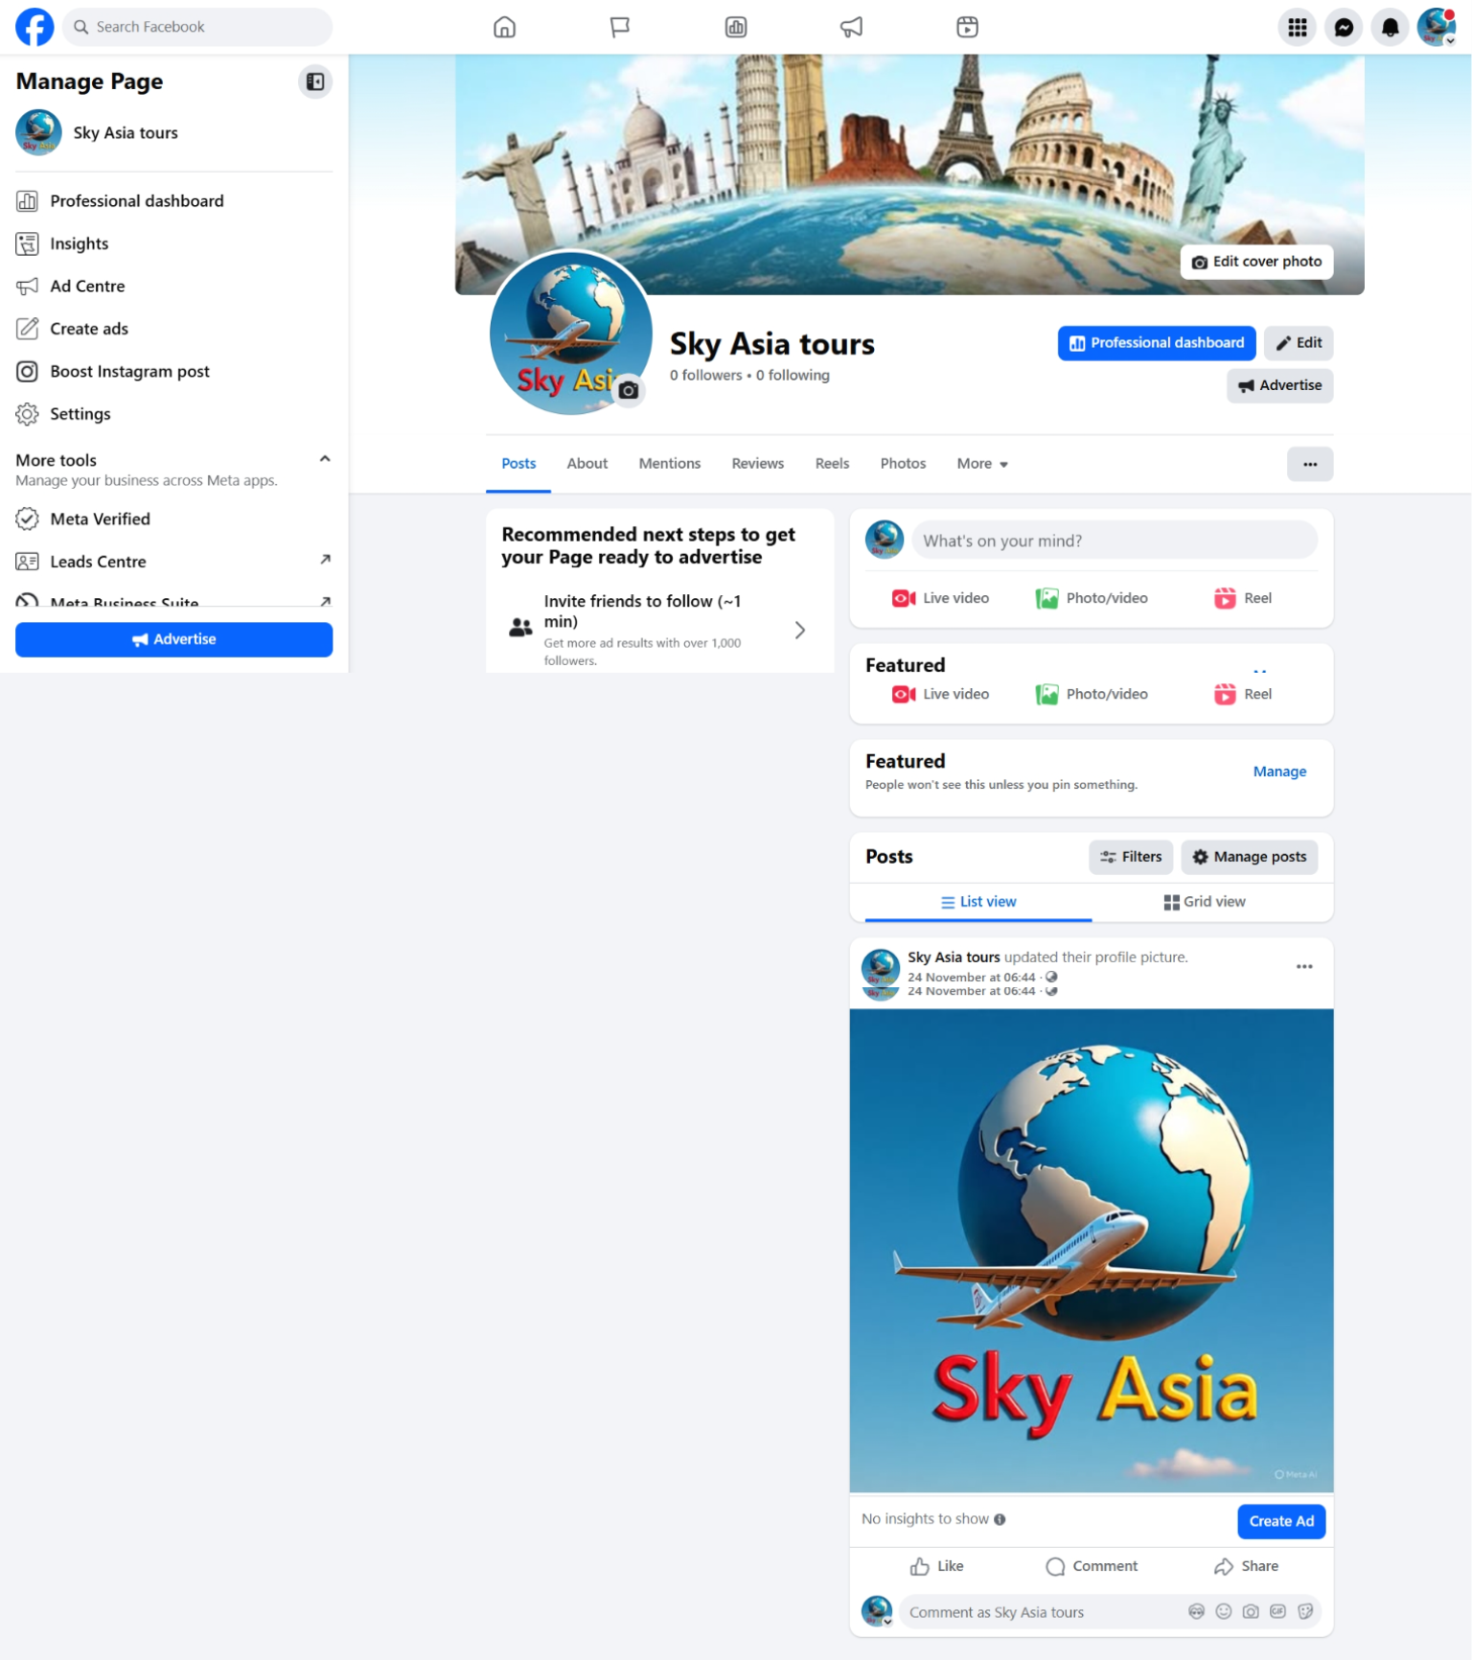

4.) AD CAMPAIGN CREATION

- Campaign objectives:
Awareness (Video Views)
Reason: This campaign aims to build brand awareness and reach more people.

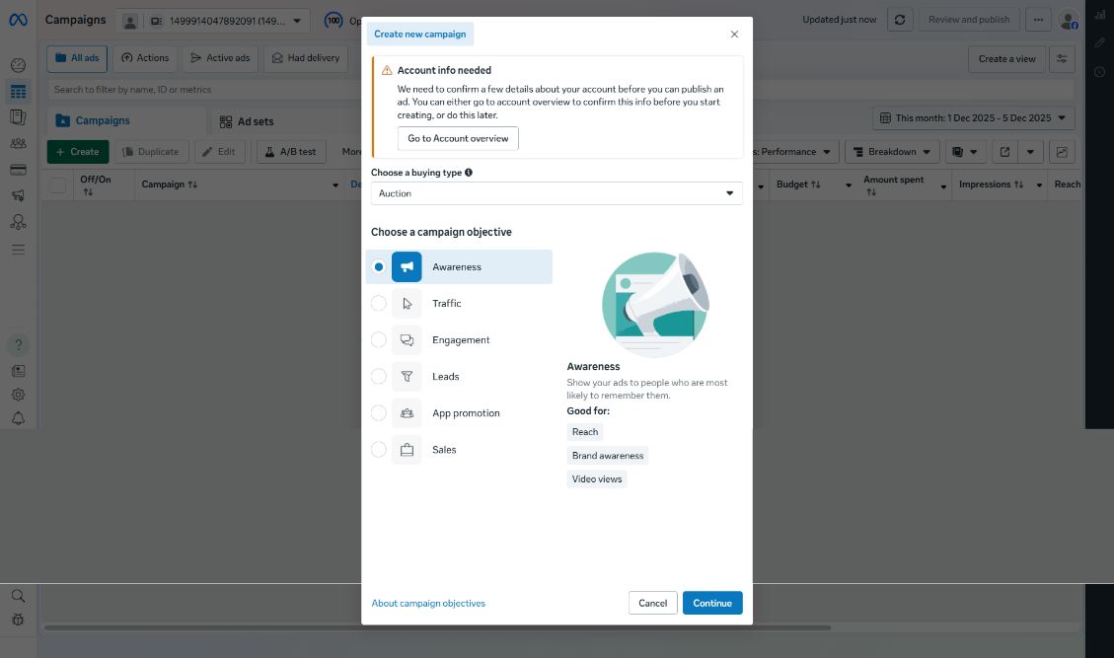

- Campaign Name:

Sky_Asia-video_awareness_campaign_dec_2025

Reason: This campaign aims to build brand awareness and reach more people.

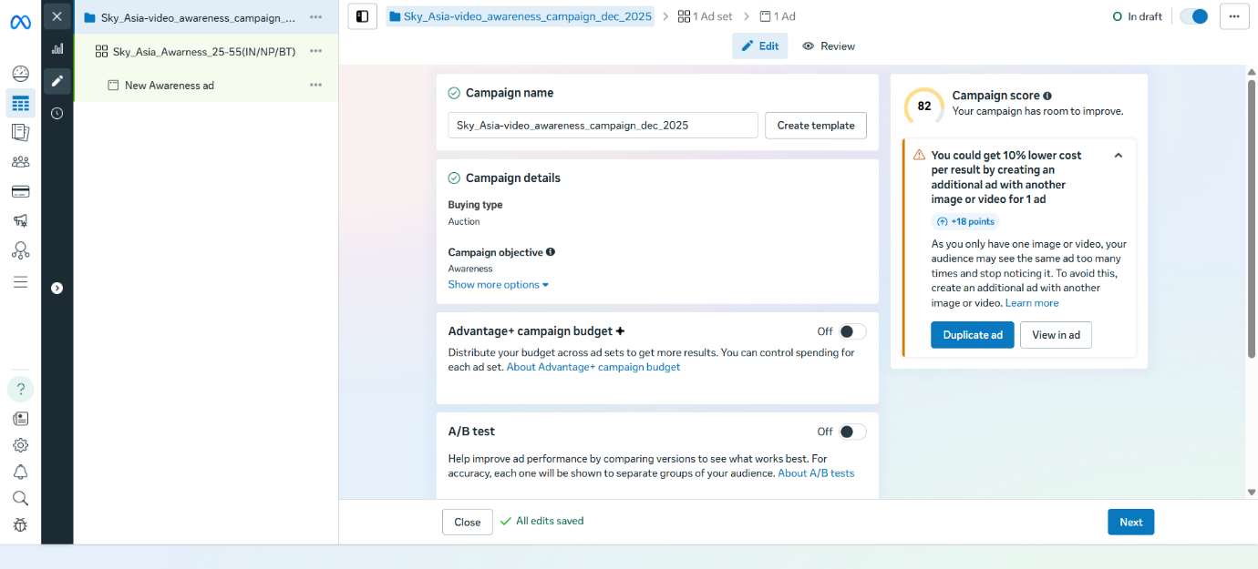

3. Audience:
Reason: This countries are Sky Asia’s markets and age
25-55 matches travel buyers, And there is no specific genders.
Mix of Interests + behaviours finds users who both travel and actively travel.

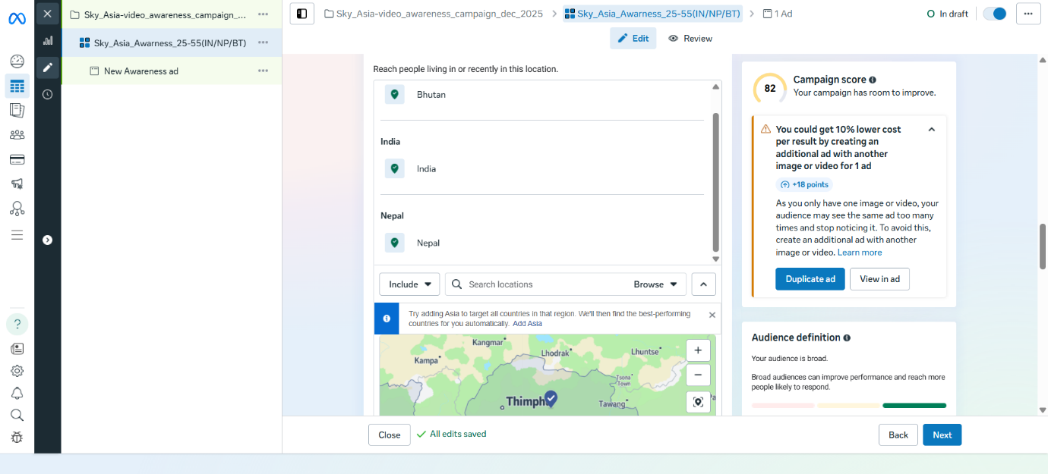

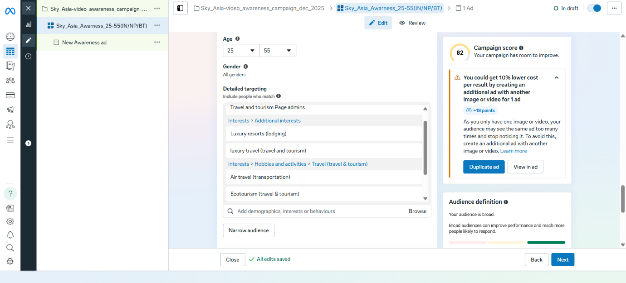

4. placements:
Reason: video content perform best on feed, reels, stories and in-stream – maximize views and engagement.

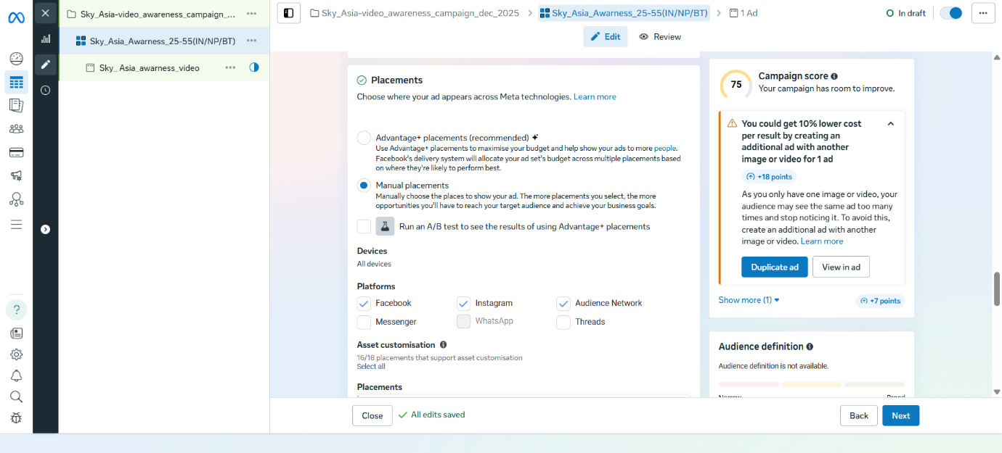

5. Budget & schedule
- Budget type: daily budget
- Daily budget: 2000
- Schedule: start 5 Dec 2025, END 5 Jan 2026 (30 days)
- Run continuously

Reason: Daily budget large enough to reach and optimize, 30 days
Gives stable delivery and helps reach targets.

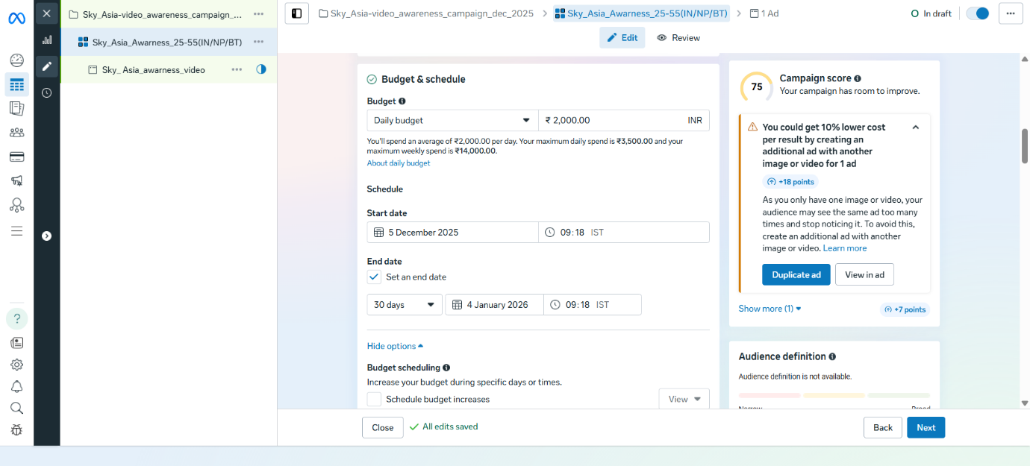

6. Ad Name
” Sky_ Asia_luxury_travel_video_ad1”
Reason: This name clearly describes the brand, type of content
(video), and is easy to identify in ads manger when creating multiple ads.

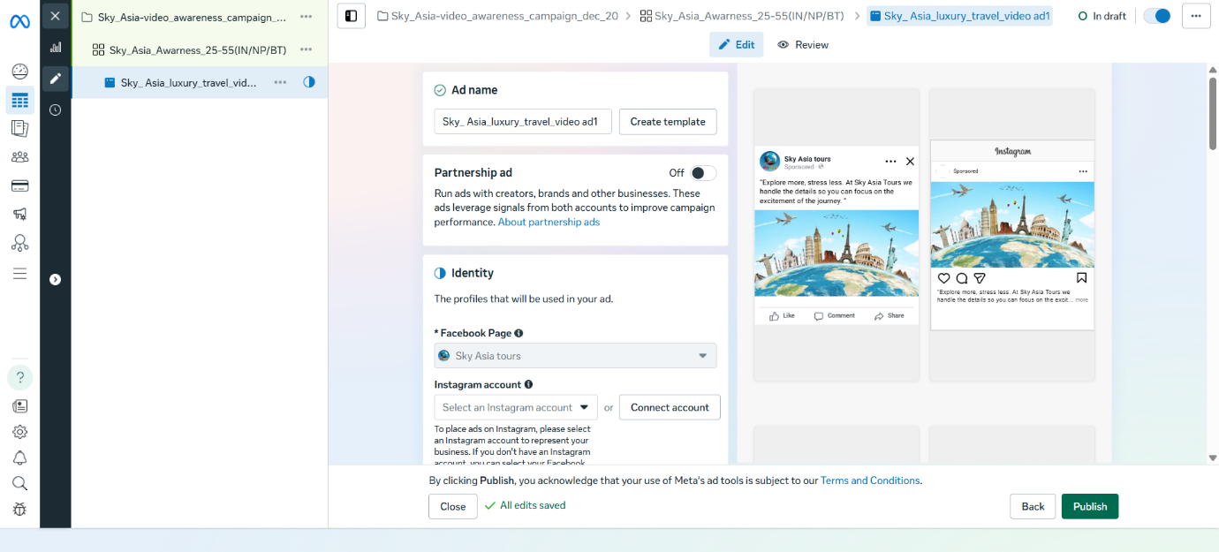

7. AD creative section
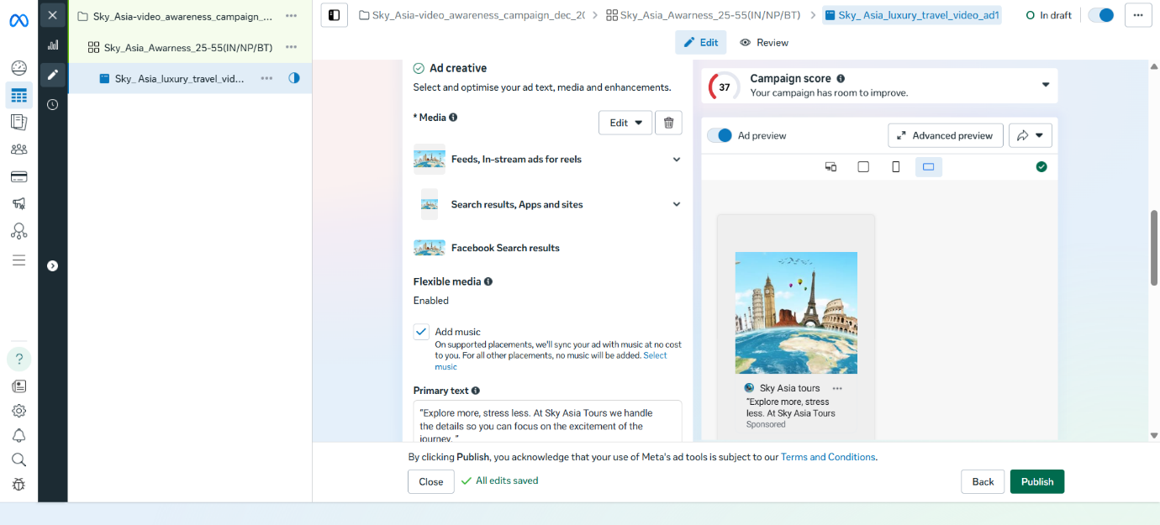

8. Metrics to track
- Reach
- Impressions
- Video views
- Cost per video view
- Engagement
- Frequency
Reason:
To measures visibility, Interest, and cost efficiency of the campaign.
6.) Duration of the campaign:
Duration :
1 month ( from 5 dec 2025 to 5 jan 2026)
Reason
A duration of one month allows the campaign to reach a larger
a larger audience over time and gives meta enough data to optimize performance.
Longer campaign help reduce advertising costs, improve reach, and maintain a balanced frequency so users see the ad multiple times without getting annoyed.
Short campaigns usually results in higher cost and limited awareness, which is not ideal for an awareness objective.

7.) Insights to track:
- Reach
- Impressions
- Video views
- Cost per result
- Engagement
- Frequency

Reason:
These metrics show how many people saw the ad, how engaged they were, and how efficiently the ad delivered results.

